VirtualEye - Life Guard for Swimming Pools to

Detect Active Drowning

<https://youtu.be/DDAJWZKbA8Q>

[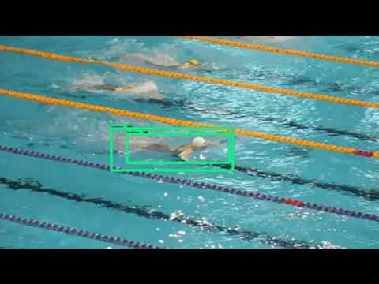](https://www.youtube.com/embed/DDAJWZKbA8Q?feature=oembed)